2021 RCLA Annual Meeting
July 10, 2021
Loch Lomond Beach Club

Call to order: The meeting was called to order by Valerie Bausch at 9:00 a.m. (approximately 49 attendees plus the board members. This is similar to previous annual meetings. Val summarized the agenda and then began a power point presentation that is an attachment to this document and contains the substantive content of the meeting.

Introduction of Current Board Officers:
President - Valerie Bausch
Vice President - Gerry Johnson
Treasurer - John Page
Secretary - Rose Kopras
Committee Directors:
AIS - Tom Goodwin / Brett Heinlein
Communications - Ryan Linder
Coupon Book - Runae Maloney
Fish Habitat - Dan Ellefson
Lake Information & Safety - Len Christianson
Membership - Sue Sleik
Nature - Valerie Bausch
Shoreline & Island Restoration - Michael Klutho
Water Quality - Tim Lewis

Absent: Ryan Linder and Sue Sleik

2021 Secretary’s Report Rose Kopras: The minutes from the 2019 annual meeting were displayed on the screen prior to the beginning of the meeting. JB made a motion to accept the minutes, Sandy Nastram seconded. Motion carried.
The 2020 minutes were distributed at the door. Louie Oakey made a motion to accept the minutes, Nichole Engler seconded. Motion carried.

2021 Treasurer’s Report John Page: John discussed the financial condition of the lake association including the income and expenses thru June 30, 2020.

Income: Total = $62,461
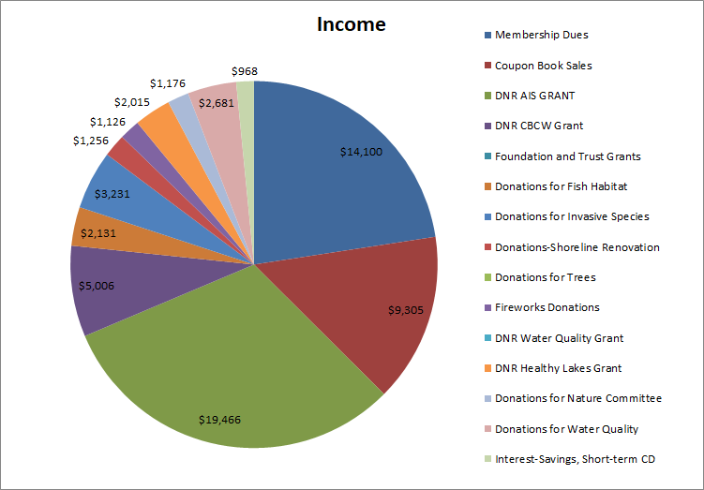

Expenses: Total = $43,333
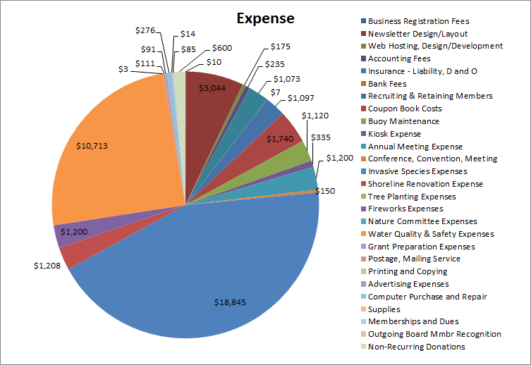

JB moved to accept the report. Dave Vohler seconded. Motion carried.

2021 Committee Reports - Directors

Nature Committee - Valerie Bausch

Identify and define educational programs
Maintain involvement with existing Nature Projects:
Loon Watch Monitoring
Wild Rice Mapping
Purple Loosestrife Monitoring
Dark Skies
Program for next year will be: “All of This and Robins Too” on Saturday June 4, 2022 from
10:00 a.m. – 11:00 a.m. Location: TBD, Presenter: Steve Betchkal.
FREE & Family Friendly!

Steve is the current President of Gaylord Nelson
Audubon Society, a Master Birder, & photographer
In 2017 he worked in the Galápagos Islands for Lindblad Expeditions-National Geographic.

Communications Committee - Ryan Linder www.redcedarlakes.com reported by Michele Fischer
- We produce a Newsletter twice a year near Memorial Day and Labor Day to keep you informed about what’s going on in our association and on our lakes
- Visit our RCLA website with updated content throughout the year
- Newsletters, Lake studies, Reports, Volunteer opportunities and events
- Facebook - RCLA Events & News Posted Frequently
- 135 Followers/123 Likes
- Community engagement & photos are encouraged!
- JOIN the RCLA page!
- Members communicate with the RCLA Board
- Email us through the website or by contacting individual committee chairs listed on the cover of our spring newsletter
- Share your pictures with us and let us know if you’d like to see them on the website or a future newsletter
- Feedback is always encouraged and welcome

Question was asked if the print paper could be cheaper: Answer: No. postal service requires the current paper that is used.

Coupon Book Committee - Runae Maloney
Coupon Book contains 76 coupons from 43 businesses

Fundraiser Statistics:
Donations: $8,240
Expenses: $1,692

350 books printed
298 mailed to RCLA members
241 returned donations

Where the books are being sold:
- Dairy State Bank Birchwood
- Butternut Hills Golf
- Birchwood Café
- Tagalong Golf
- Cedar Lake Grill

Thank you to the 43 local businesses that support the RCLA with their coupons.
Thank you to the Rice Lake Printery for their help in design, layout, printing, assembly and mailing.
Thank you to all of you for donating to our fundraiser.

Fish Habitat Committee - Dan Ellefson

Fish Sticks Installations - Summer 2020
William J. Petersen Trust
Mikana Marine & Resort

Lake Information & Safety Committee - Len Christianson

BE A RESPONSIBLE WATER SPORT PARTICIPANT BY COMPLYING WITH THE WSIA (WATER SPORT INDUSTRY ASSOCIATION) GUIDANCE FOR WAKE BOAT OPERATORS.
Maintain a minimum distance of 200 feet from any shoreline and others enjoying the lake.
RED CEDAR LAKES ASSOCIATION RECOMMENDS 400 FEET.
Minimize repetitive passes in the same area.
Keep music at reasonable levels.
Remember your wake has an impact on:
- Property damage
- Shoreline erosion
- The lake bed and wildlife habitat
- The safety of others on the lake
- The transportation of AIS (Aquatic Invasive Species)
in the ballast tanks and on trailers

If you witness boats violating distance laws call the Sheriff’s Department:
On Red Cedar and Hemlock 715-537-3106
On Balsam Lake 715-468-4720
Or Wisconsin DNR Enforcement 1-800-847-9367
Take the test. Go to WSIA.NET/WAKE-RESPONSIBLY
for more information on how you can keep our lakes safe and your sport friendly.
The Red Cedar Lakes Association is NOT responsible for enforcement of boat or lake violations. Please call the Sheriff or WI DNR.

Membership Committee – Sue Sleik reported by Valarie Bausch

We currently have 645 members in 2021 compared to 654 in 2020. Thank you to those of you that have renewed your RCLA memberships and to the 65 new members who have joined!
Membership income is $13,760 and donations are at $10,691
Corporate Members - please thank these businesses for their support
- Birchwood Café
- Cedar Lakes Grill
- Cedar Ridge Wealth Management
- Cheers
- Dairy State Bank
- The Gathering Place
- Loch Lomond Beach Club
- Mikana Marine & Resort
- Pines at the Lake
- Thomas Marine

Shoreline & Island Restoration Committee – Michael Klutho

- Awarded 9 grants from DNR to construct...
- 4 rain gardens,
- 4 native plantings and
- 1 rock infiltration project
- Each will help reduce direct water runoff into our lakes and thereby improve and maintain
lake quality

Looking ahead...2021-2022
Identify and solicit interest from additional lakeshore owners to participate in a “Healthy Lakes" grant application for 2022, and if awarded constructed in 2023-24.

Assess islands to determine erosion and possible remediation.

Water Quality Committee - Tim Lewis
Water Quality can be best described as...
- High level of clarity
- Low levels of phosphorous
- Sustainable fisheries and wildlife habitat
- Quality recreational opportunities (e.g., swimming, boating, etc.)
- ALL OF THE ABOVE AND MORE...

Key Focus in 2021 Includes...
Volunteers to regularly sample water on each of the 3 main Lakes and 5 streams and report to Citizen Lake Monitoring Network
Coordinate with WDNR and outside consulting services to identify further testing instruments and locations
Received 2 Water Quality Grants for $75K

Monitoring...PO4

Aquatic Invasive Species Committee - Tom Goodwin & Brett Heinlein

Good News! Aquatic Invasive Species remain stable in our lakes. We continue to have just four species of AIS (Curly Leaf Pondweed, Chinese Mystery Snails, Purple Loosestrife and Rusty Crayfish)
Zebra mussels and Eurasian Milfoil are in neighboring lakes and probably our biggest threats

2019 – 2021 Grant:
Provides up to $180,885 (state funding) for AIS control and water quality studies
Remaining funding - $131,254 (state funding)
Current grant runs through June 2022
Will be requesting grant extension to use remaining funds
2021 AIS Actions:
- CLP herbicide treatment in the channel between Balsam and Red Cedar Lakes
- 2.4 water acres treated in May

2021 AIS Actions:
- CLP bed mapping was completed by Freshwater Scientific Services in June
- Shoreline property studies for Hemlock and Bass Lake
- Woody debris studies for Hemlock and Bass Lakes
- Ongoing monitoring of AIS through the summer
- Zebra mussel plates
- Raking weeds near boat landing and stream entrances
- Eradication of Purple Loosestrife
- Hand removal during July & August by Nature Committee
- CLP turion study to be completed this fall by
Freshwater Scientific Services

CLP Treatment Application

August 28th Education Meeting
Topics to include:
- Lake water quality update
- Healthy lakes initiatives & opportunities
- Aquatic Invasive Species Update
- Fish Sticks program

Clean Boats, Clean Waters — AIS Brett Heinlein
Landing monitoring: V & 48, Waldo Carlson, Hemlock, Loch Lomond Beach Club
Decontamination Stations at Waldo Carlson, Loch Lomond Beach Club, Hemlock and Balsam

Volunteers Needed
Red Cedar Lakes Association needs to achieve 400 hours of landing monitoring to qualify for our grants
RCLA pays $12 per hour for landing monitoring
For more information contact Brett Heinlein: (414) 254-0810
bwheinlein0810@gmail.com

President’s Direction Valerie Bausch: 2021-2022
- A “BIG TIME” THANK YOU to all of our members who have volunteered on our many projects and committees
- Continue to Build our RCLA Budget Equity Position for anticipated AIS Emergency Response Plan expenditures
- Volunteers are Needed!

Financial Report — Net Worth at Year End
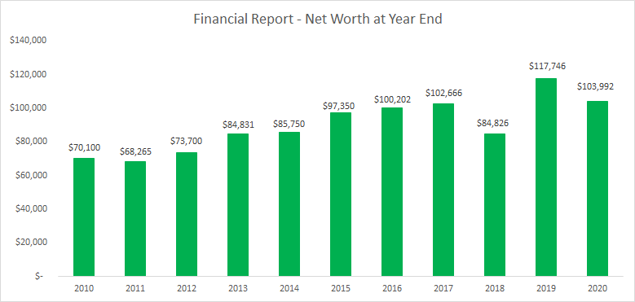

Farewell to Board Members
- Ryan Linder - Communications
- Dan Ellefson - Fish Habitat
- Sue Sleik – Membership

Election of Board Members 2021-2022

Renewing Board Members
Board Officer Renewing
for 3-Year Term:
- No renewals required
Board Directors Renewing
for 2-Year term:
- Valerie Bausch – Nature
- Michael Klutho - Shoreline & Island Restoration
- Brett Heinlein - AIS Co-Chair
Change in Board Director Role:
- Runae Maloney – Moving to Membership Chair

Michelle Fischer - Communications
- Born in Fargo, ND
- Currently live in Dayton, MN with my wife Carol
- I have two adult sons: Fischer and Spencer
- Carol & I purchased land on Hemlock Lake west of the boat landing last November
- I’m a special education teacher at Osseo Senior High school and I work with students who have developmental cognitive disabilities
- My former career was in graphic design
- My heart is full and I’m at peace when I’m out
in nature, especially at the lake!
- I’m thrilled to be a part of this association and RCLA board
- I’m looking forward to using my graphic design skills again on the newsletters and website

Tim Plaza - Fish Habitat
- Live full-time on Balsam Lake with my wife Sue.
- Born and raised on a dairy farm in Hawkins, WI.
- The family purchased a cranberry marsh in Rusk County
in 1971 and I worked developing it ,as President of Plaza
Cranberry Farms, Inc. We grew cranberries for Ocean
Spray for 43 years until my retirement in 2014.
- We retired to Birchwood, as I fished the Red Cedar
Chain of Lakes for 35 years and my wife's family was
originally from Rice Lake and Birchwood.
- I am an avid fisherman and spend a lot of time in my
woodworking shop where I enjoy working on projects
when it's too miserable to fish.
- Our travel plans have been recently curtailed, but we are
anxiously anticipating more travel adventures.
- My wife and I have two sons (also life-long fishermen), their
wives (apprentice fisherwomen) and four young grandchildren
(fisher kids in training).
- Looking forward to having the opportunity to work with the Board and improving the habitat on the lakes for everyone to enjoy.

Kathy Salvi - Coupon Book
- Residences: WI: Mikana (Red Cedar Lake) / Mooresville NC (Lake Norman Area)
- Occupation—Retired
- Grandchildren: 6 girls (Our daughter and her husband
were married on Stout’s Island)
- Hobbies: Fishing, Gardening, Cooking, Reading,
Bird Watching
- Reason for joining: As new residents, our family used our coupon book as an introduction to the surrounding areas. The coupon book served as an opportunity to meet new people, explore different places, and support our local businesses. I am excited to share my personal experiences with others as an example the impact the book can have. I look forward to getting to know the people in our area on a more
personal level. I believe now more than ever that everyone has a contribution to make, and I look forward to finding out what mine can be to my new community.

Sandy Nastram made a motion and Doris Christensen seconded to accept the new board members. Motion carried.

RCLA Board of Directors
Officers:
President - Valerie Bausch
Vice President - Gerry Johnson
Treasurer - John Page
Secretary - Rose Kopras

Directors:
AIS - Tom Goodwin
Co-AIS - Brett Heinlein
Coupon Book - Kathy Salvi
Fish Habitat - Tim Plaza
Island & Shoreline Restoration - Michael Klutho
Lake Information & Safety Committee - Len Christianson
Membership - Runae Maloney
Nature - Valerie Bausch
Communications - Michelle Fischer
Water Quality - Tim Lewis

Q&A / Adjournment: JB made a motion to adjourn at 10:33, Debra Rowe seconded, Motion carried.

Other questions:
What are the other impacts from wake boats, and pontoons with more powerful motors. How do we keep lights on docks dim?
Can we use facebook more? We can ask members for their email addresses and use them if provided.
How do we ensure homes that are rented share the lake rules? Renting required registration.

